**A Synopsis on**

**“MULTISPECTRAL SATELLITE IMAGE DEHAZING”**

**Submitted in partial fulfilment for the award of the degree of**

**BACHELOR OF TECHNOLOGY IN**

**COMPUTER SCIENCE AND ENGINEERING (DATA SCIENCE)**

**Submitted by**

**1. Shaishta M (19BTRCR014)**

**2. Naga Kushal Ageeru (19BTRCR047)**

**3. G Sai Avinash (19BTRCR048)**

**4. Nishen Ganegoda (19BTRCR061)**

**Signature of Guide: Signature of Student(s):**

**1.**

**2.**

**Signature of Program Coordinator 3.**

**4.**

**Faculty of Engineering & Technology Jain (Deemed-To-Be University)**

**Department of Computer Science & Engineering Jain Global Campus, Kanakapura Taluk - 562112 Ramanagara District, Karnataka, India**

**2021-2022**

**Introduction**

* In recent years there has been a growing interest in using satellite imagery for different tasks in modeling the earth, e.g., creating accurate maps. For this to be possible the satellite images must have a high enough resolution to be able to detect small details.
* The usability of the images does not only depend on their resolution but heavily on the quality of their content as well.
* One great disadvantage when taking images from outside of the atmosphere is that the result will be distorted since the light is forced to pass through particles in the atmosphere which will scatter and absorb the light.
* The distortion will reduce the applicability of the resulting images if they are not corrected. Since these effects are inevitable in the field of remote sensing it is important to have effective methods to remove them.
* A multispectral image dehazing tries to improve interpretability in the image regions affected by the presence of haze during acquisition.
* In remote sensing, optical multispectral satellite images often suffer from the presence of haze resulting in a lack of contrast and data interpretation.
* The process of dehazing tries to recover the information affected due to the presence of haze and therefore servers to increase the data interpretation for manual or automated operations. Haze detection and removal is a challenging and important task for optical multispectral data correction.

**Literature Survey/Review**

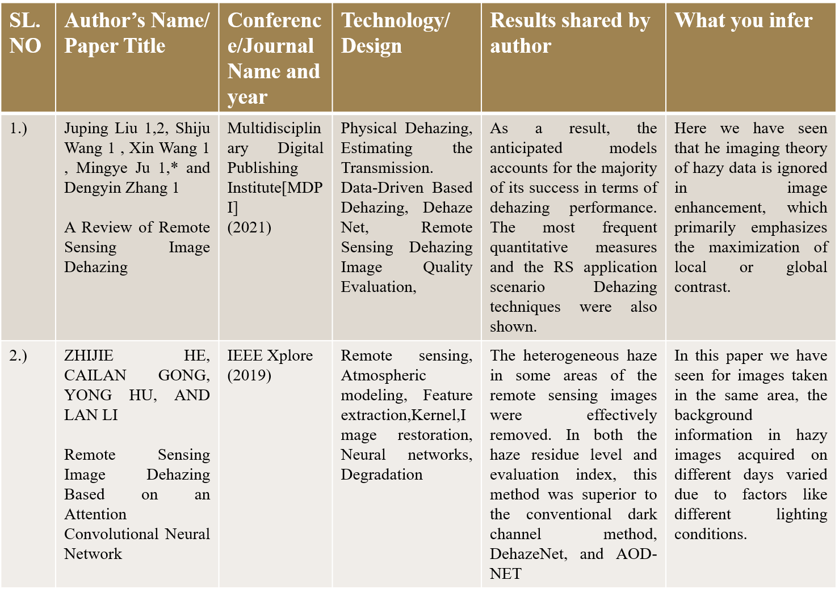

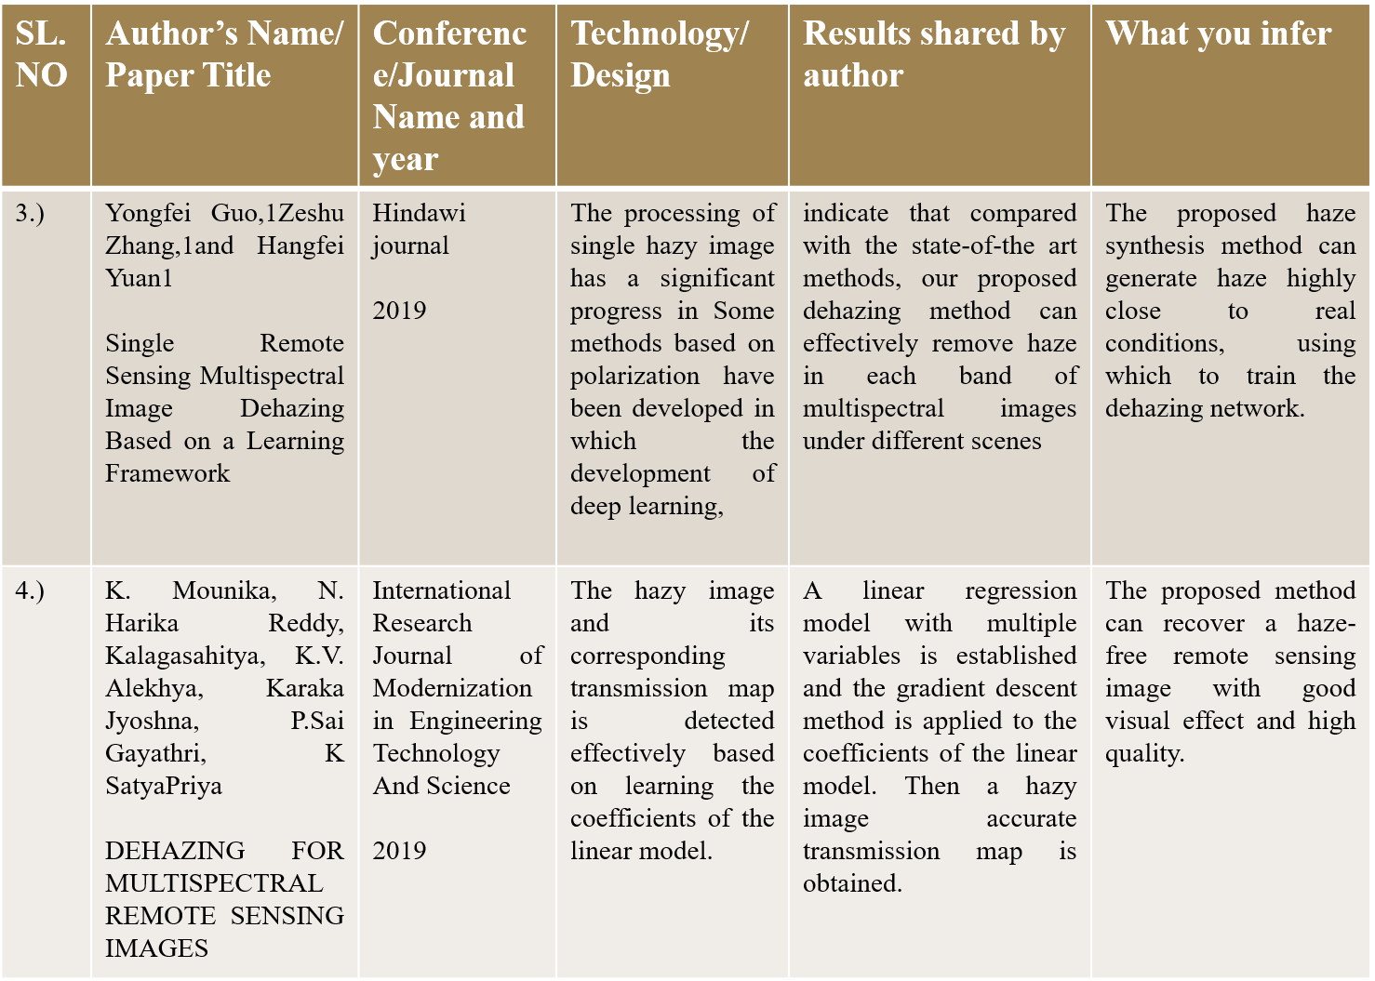

**Proposed methodology**

The Novelty which we have included in our project is the testing of different methods to implement denization and coming out with the best method from it.

Architecture:

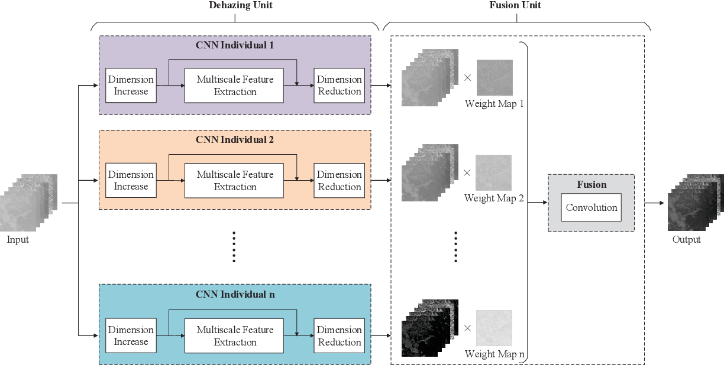

The flow chart below represents the complete procedure of the project.

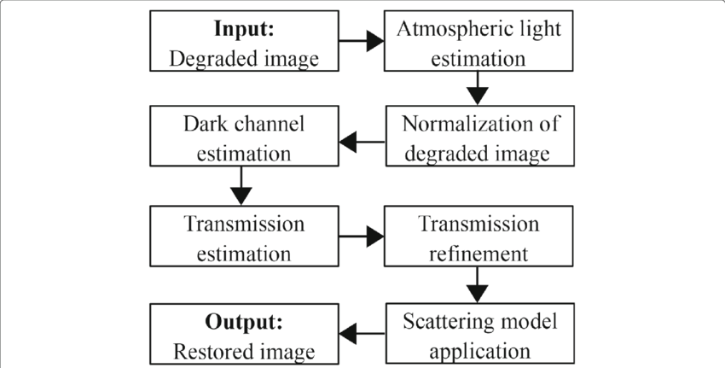

Functional Requirements

* Good quality dehazed image and help users fully understand the information from the image dataset.
* The system should be able to do the following:
* The system accepts the inputs hazed image and extract.
* Provide a improvised version of the image with higher quality.
* Allow users view and download the clear image.

Non-Functional Requirements

* User friendly web interface.

The proposed project model is reliable as it classifies and generates text description of an image and audio signal.

* The proposed project model is robust as it undergoes data training.
* Basic interpretation of data over a given period.
* Provide basic analysis of the values read.
* Availability
* Good Accuracy

Software/System Requirements

System requirements

* Operating system: WINDOWS/LINUX/MAC
* RAM: 4-8GB
* 80 GB HDD
* GPU:4GB(NVIDIA/AMD)

Software Requirements

* Visual studio
* Python version 3 and above version
* Java version 8
* Python libraries (Numpy, pandas, sklearn, scipy, keras, TensorFlow).

**Future Scopes/ Applications**

1. A novel and effective dehazing project will developed to achieve remote sensing image haze removal.
2. User friendly web interface.
3. A machine learning CNN model to improvise the hazed image.
4. Web interface which works well on most devices.
5. The research on video dehazing should be done.
6. Video dehazing methods should be the improvement of single dehazing image methods.

**References**

[1.] Liu J, Wang S, Wang X, Ju M, Zhang D. A Review of Remote Sensing Image

Dehazing. Sensors (Basel). 2021 Jun 7;21(11):3926. doi: 10.3390/s21113926.

PMID: 34200320; PMCID: PMC8201244.

[2.] Z. He, C. Gong, Y. Hu and L. Li, "Remote Sensing Image Dehazing Based on

an Attention Convolutional Neural Network," in *IEEE Access*, vol. 10, pp.

68731-68739, 2022, doi: 10.1109/ACCESS.2022.3185627.

[3.] Hindawi. “Single Remote Sensing Multispectral Image Dehazing Based on a

Learning Framework.” Single Remote Sensing Multispectral Image Dehazing

Based on a Learning Framework, www.hindawi.com/journals/mpe/2019/4131378.

Accessed 22 Sept. 2022.

[4.]www.irjmets.com/uploadedfiles/paper//issue_6_june_2022/26642/final/fin_irj

mets1655902241.pdfhttps://www.irjmets.com/uploadedfiles/paper//issue_6_june_

2022/26642/final/fin_irjmets1655902241.pdf.

[5.] Jisnu, K.K., & Meena, G. (2020). Image DeHazing Using Deep Learning Techniques. *Procedia Computer Science, 167*, 1110-1119.

[6.] B. Huang, Z. Li, C. Yang, F. Sun and Y. Song, "Single Satellite Optical Imagery Dehazing using SAR Image Prior Based on conditional Generative Adversarial Networks," *2020 IEEE Winter Conference on Applications of Computer Vision (WACV)*, 2020, pp. 1795-1802, doi: 10.1109/WACV45572.2020.9093471.

[7.] M. Qin, F. Xie, W. Li, Z. Shi and H. Zhang, "Dehazing for Multispectral Remote Sensing Images Based on a Convolutional Neural Network With the Residual Architecture," in *IEEE Journal of Selected Topics in Applied Earth Observations and Remote Sensing*, vol. 11, no. 5, pp. 1645-1655, May 2018, doi: 10.1109/JSTARS.2018.2812726.

[8.] Akash Ramjyothi, Santonu Goswami. CLOUD AND FOG REMOVAL FROM SATELLITE IMAGES USING GENERATIVE ADVERSARIAL NETWORKS (GANs). 2021. ⟨hal-03462652⟩